Bronchial:

auscultated over anterior chest and heard over *tracheal area*

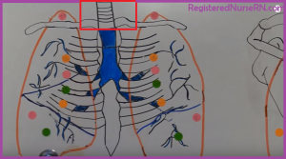

Bronchi Vesicular :

**Found where?** auscultated anteriorly and posteriorly and heard over the *bronchi*

* anteriorly: ***1st and 2nd intercostal space near the sternum***
* posteriorly: ***between the scapulae***

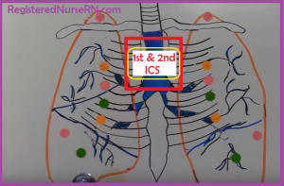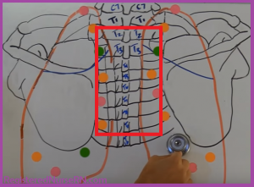

### **Vesicular:**

**Found where?** auscultated anteriorly and posteriorly and heard over ***peripheral lung fields***

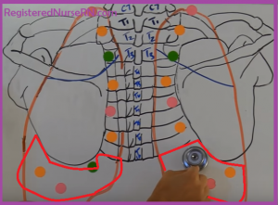

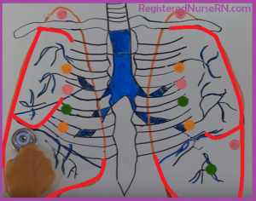

Instead of Vesicular if bronchial is sound is heard in the place where vesicular sound should be heard then it denotes a disease called “Consolidated lung pneumonia”.